
Plant Care Guide

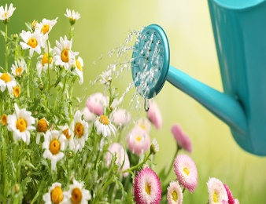
Watering New Plants:
1. Year 1: (Spring-Fall):
When Planting: Water plants as soon as you get them in the ground. Allow the water to soak in, then water again until the soil is thoroughly moistened.
Week 1: Water plants daily.
Week 2, Onward: Unless the weather is extremely hot and dry, you may decrease watering frequency to two or three times per week until the fall.
Summer Months: The first two summers for a new plant are the most important for plant establishment. During late June through early September plants may need an extra watering per week, especially in extreme heat and drought.
- Years 2 & 3: Water deeply once or twice per week. How often and how long you water depend on your soil composition. In extreme heat and dryness 2-3 waterings per week might be required.
- After year 3: Plants should be established and thrive with less watering. Drought-tolerant plants may need no supplemental water.

*Tip: One way to calculate how much water to apply is to look at the container size of the new plant. Typically, 2/3 of the given container size is what you should be applying at each watering.
  - For example, a 45 gallon-sized tree would require about 30 gallons of water.
*Tip: While getting established, deeper and infrequent watering helps plants grow healthy extensive roots that stand up better to drought stress.

Watering New Sod:
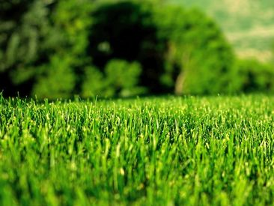
Week 1: Apply 1.5 inch of water twice per day (typically this would be an average of 15-25 minutes per zone depending on water pressure and the type of sprinkler heads).
Weeks 2-3: Water once per day for the second and third week.
After week 3: Water 3 times per week until the lawn is established.
*Tip: As with plants, after the first couple of weeks it is better to have a few deep waterings per week than shallow waterings every day. This encourages deep root growth and strengthens the sod to hold up to drought better.

Plant Types:
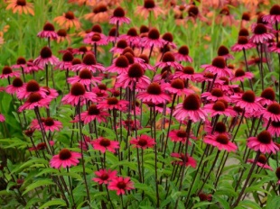
Annuals: Plants with a life cycle that lasts only one year. They grow from seed, bloom, produce seeds, and die in one growing season. Plant at the beginning of the growing season (March for Spring flowers, June for summer flowers, and October for winter flowers)
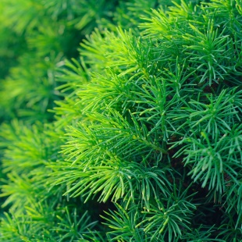
Perennials: Plants that return year after year and continue growing until they reach maturity. Generally the top portion of the plant dies back each winter and regrows the following spring from the same root system. Plant container-grown perennials year-round, but it is best to plant at the beginning of Spring
Deciduous: Perennial plants that lose their leaves in the dormant season. It is best to plant deciduous shrubs and trees in the fall right before dormant season or in the winter during the dormant season, but container-grown plants can be planted year-round with relatively little transplant shock.
Evergreen: Perennial plants that maintain their foliage year-round. Plant container-grown evergreen trees and shrubs year-round but the best time is fall and winter.

Pruning/Trimming: Any major trimming should occur during the dormant season (November-February) to reduce stress on trees and shrubs. Seasonal pruning is recommended for blooming perennials and shrubs, directly after a blooming cylce to encourage repeat blooms.
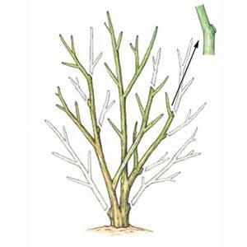
- Thinning cuts remove an entire branch where it meets another limb, the main stem, or the ground. They should be made as close to this junction as possible. These cuts help maintain the plant's natural shape, limit its size, and open up the interior branches to light and air.


Plant Care Contract:

I, , hereby accept the terms and conditions of the Plant Care Guide. I acknowledge that if I fail to follow the basic steps to watering and overall plant care, replacement plants will not be provided. I acknowledge that replacements plants are only provided, given the replacement is within one year of the planting time, and proper care has been provided to prevent any loss or damage to the plant.


Signature: ________________________________________________ Date:_____________________

972.236.3076 sam@allseasonslandscapetx.com

